Implementation of 8 bit Ring Counter

LAB # 06



Spring 2024
CSE-308L Digital System Design Lab

Submitted by: Ali Asghar
Registration No.: 21PWCSE2059
Class Section: C

“On my honor, as student of University of Engineering and Technology, I have neither given nor received unauthorized assistance on this academic work.”

Submitted to:
Dr. Asif Ali Khan

Date:
14th April 2024

Department of Computer Systems Engineering
University of Engineering and Technology, Peshawar
Objectives:
This lab will enable students to:
- To become familiarized with behavior level modeling
- To be able to implement sequential circuits using Verilog.
- To Implement an 8 Bit Ring Counter on Spartan 6 FPGA starter kit.

Software used:
- ModelSim

Clock Divider:
A clock divider is a circuit that takes an input clock signal and generates an output clock signal with a lower frequency. These circuits are commonly used in digital systems for various purposes, such as generating slower clock domains, creating timing signals, or driving sequential logic elements.
For simulation purposes, I have generated a 100 GHz signal and divided it by 100 to get 1 GHz output signal.

Code:
DUT Code:
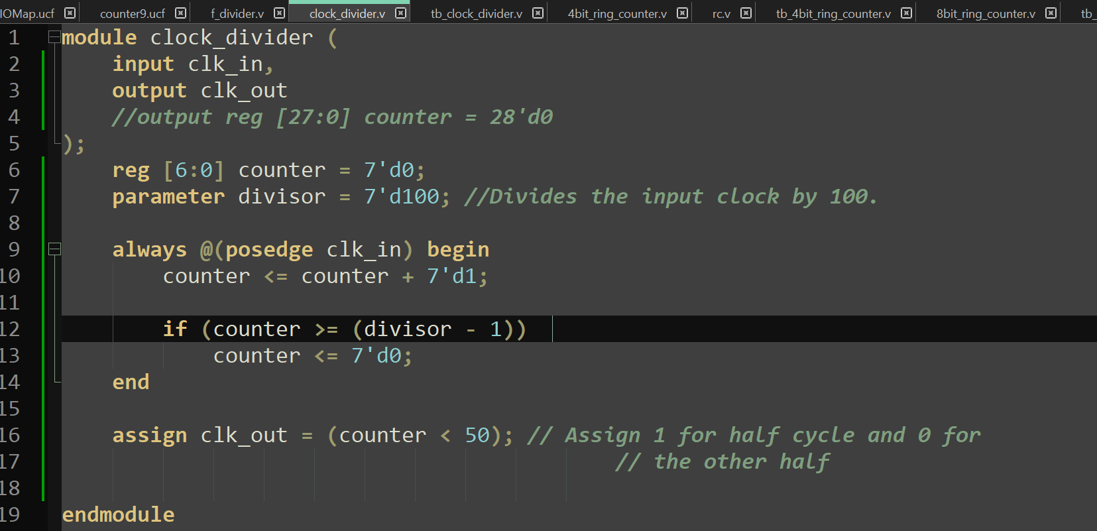
Test bench Code:
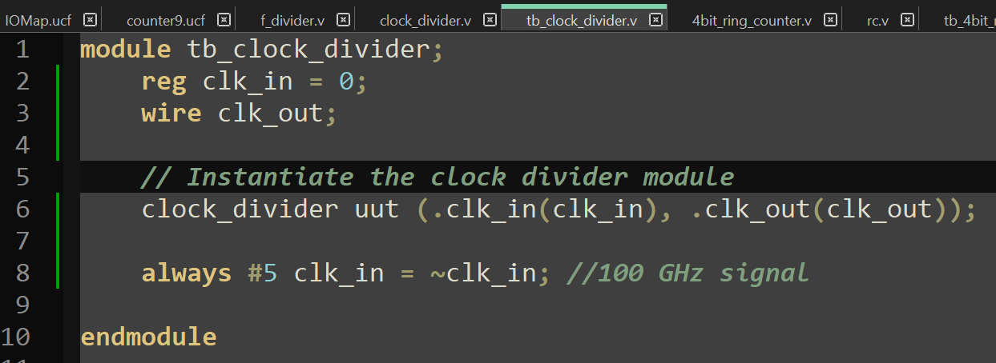

Output:
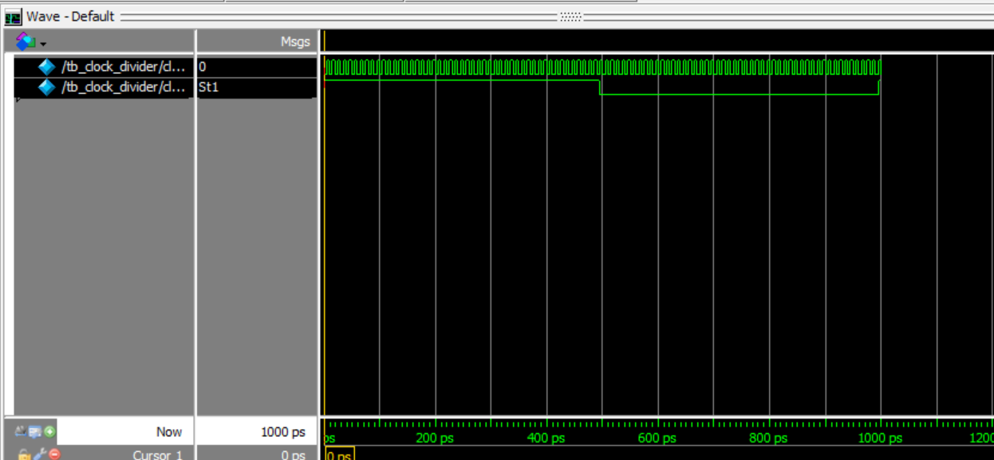

Task 1:
Implement 4-bit Ring Counter

Code:
DUT Code:
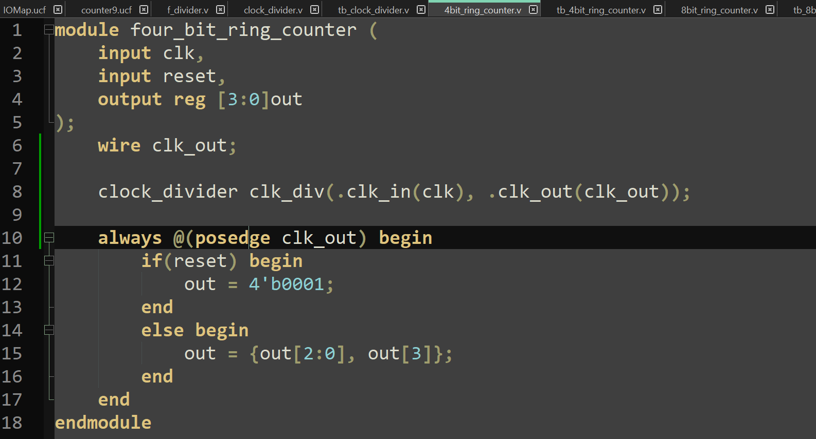

Test bench Code:
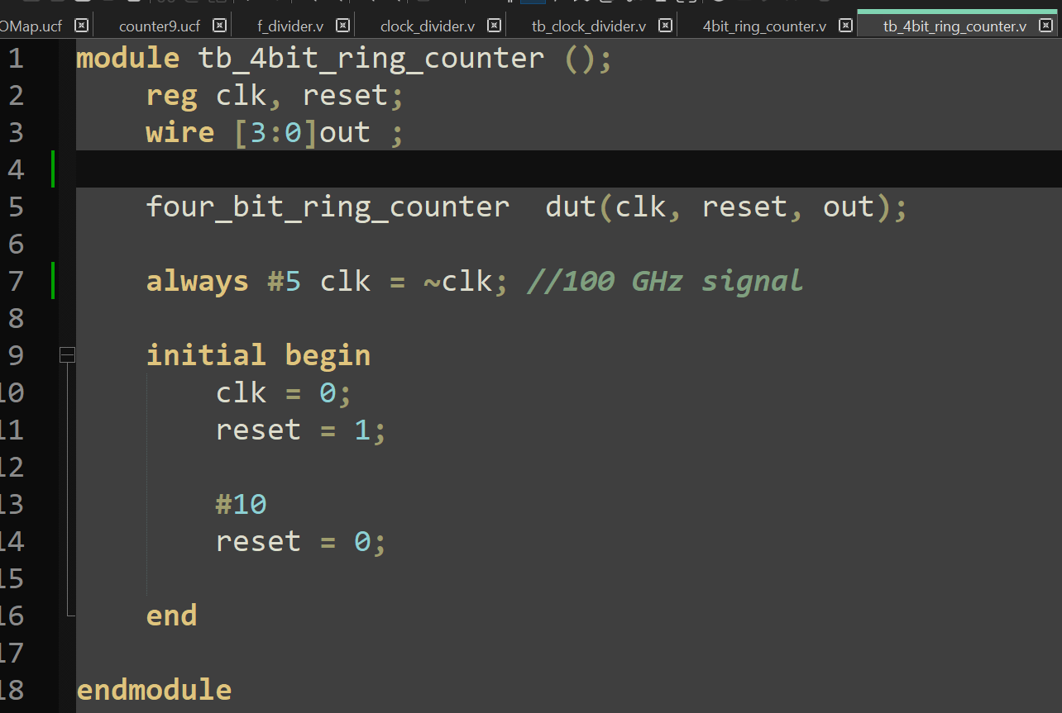
Output:
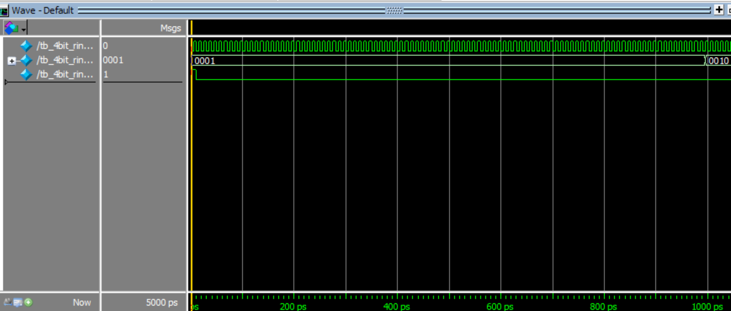
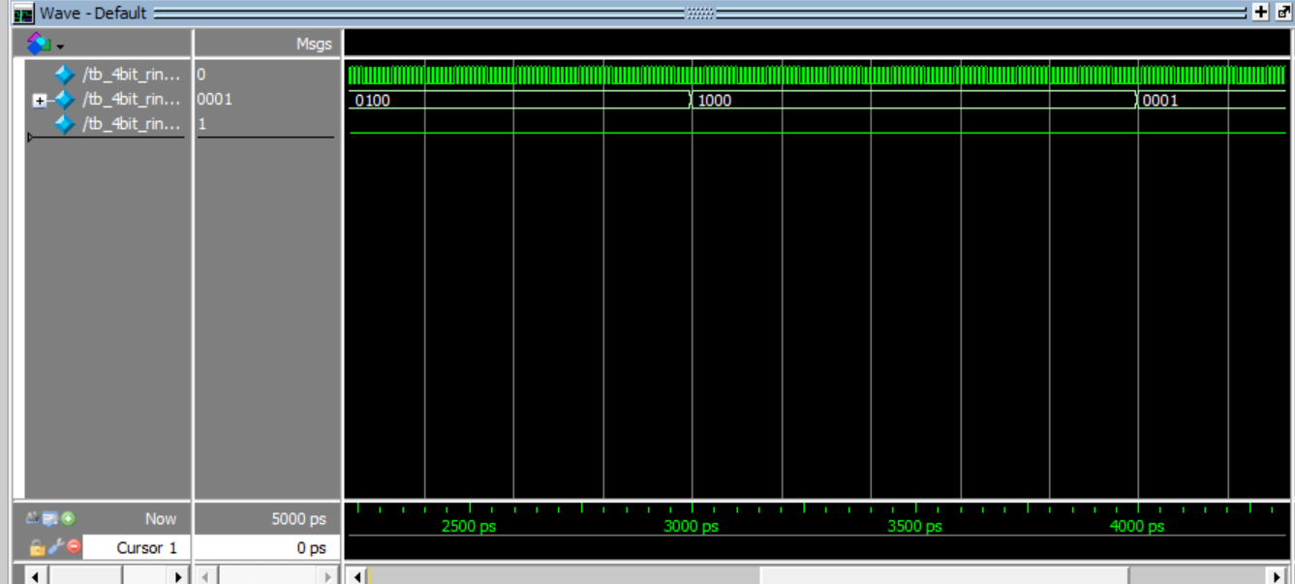

Task 2:
Implement 8-bit Ring Counter

Code:
DUT Code:
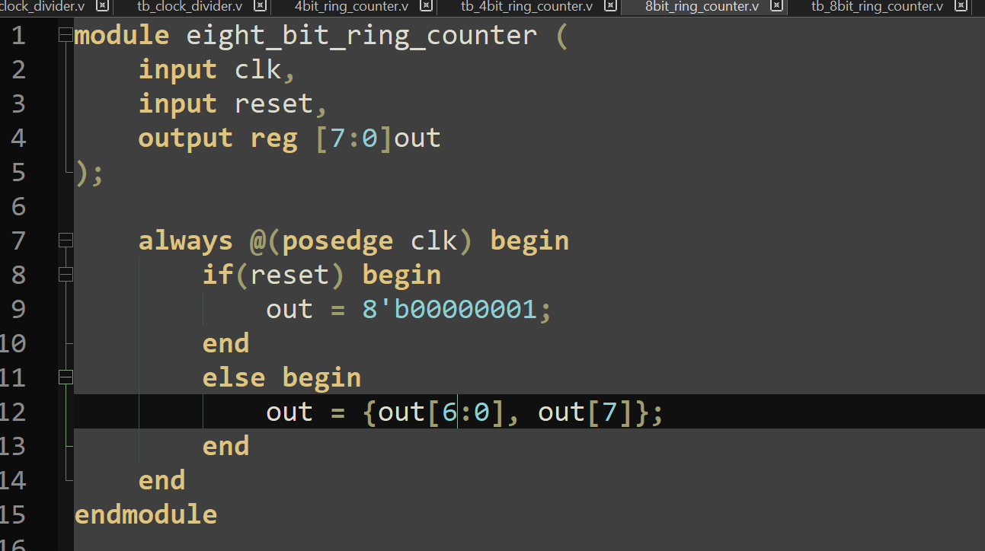

Test bench Code:
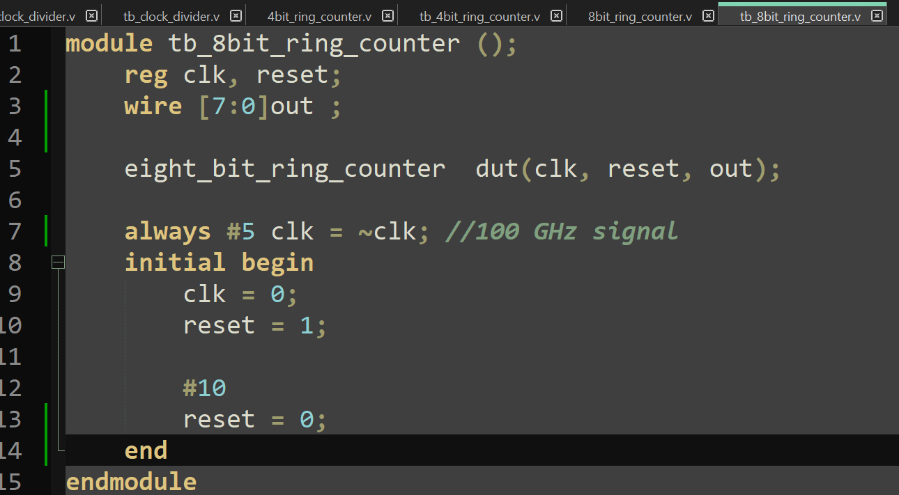
Output:
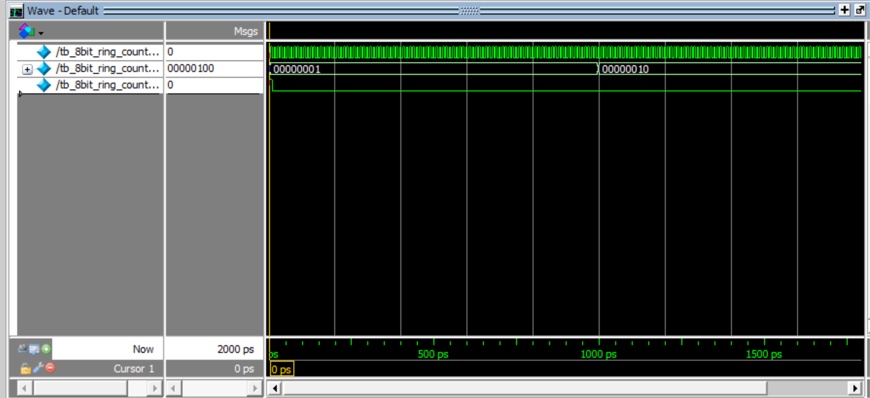

Task 3:
For both the counters display the count in the seven-segment display.

Code:
DUT Code: (For 4-bit Ring Counter)
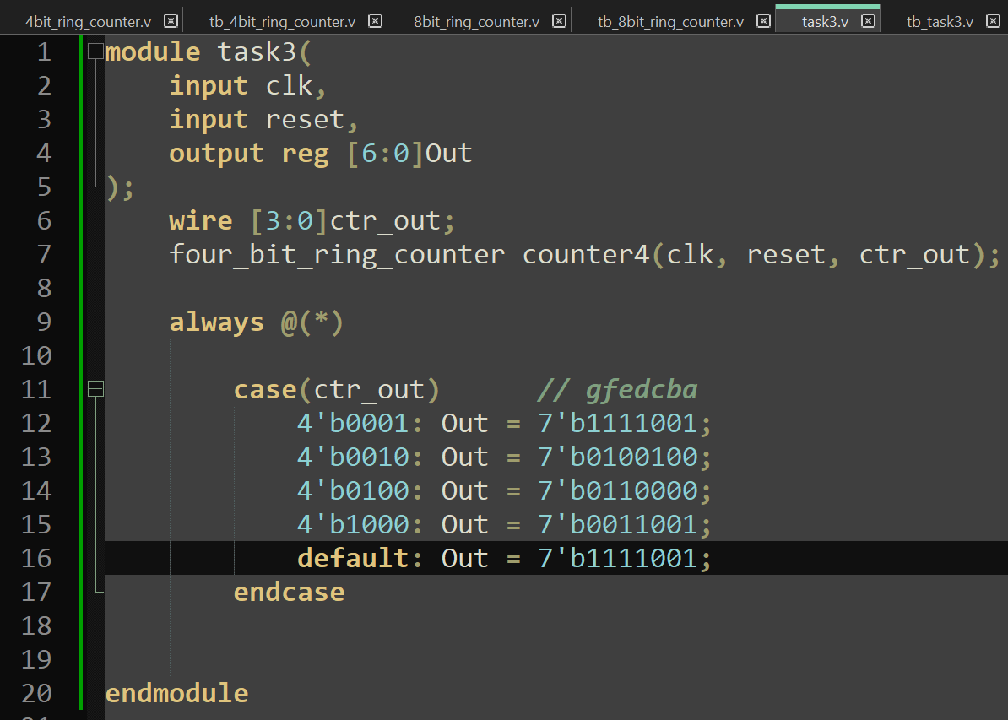
Test bench Code: (For 4-bit Ring Counter)
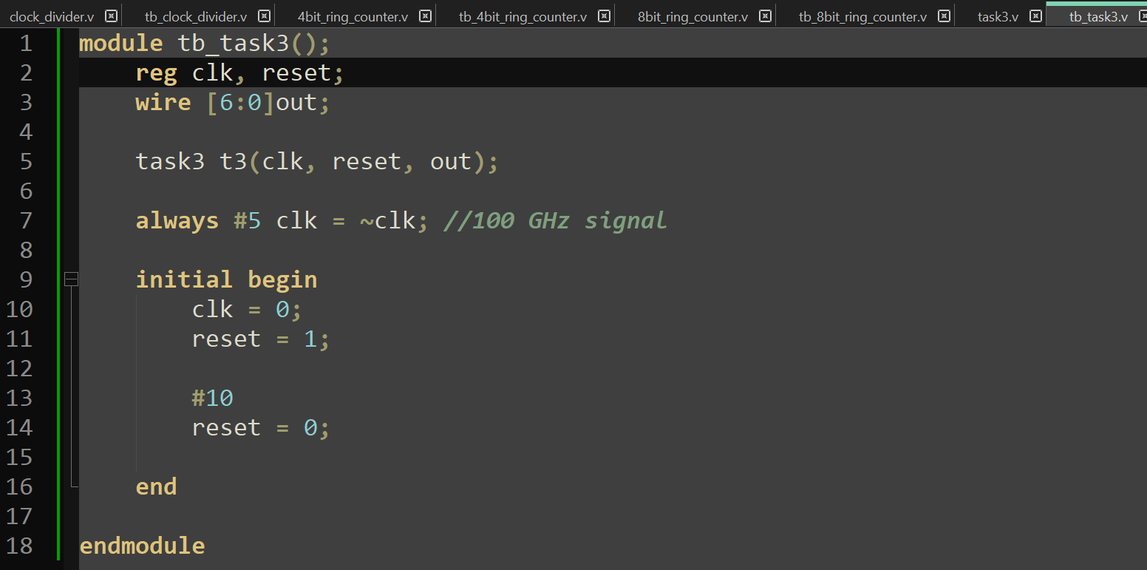

Output: (For 4-bit Ring Counter)
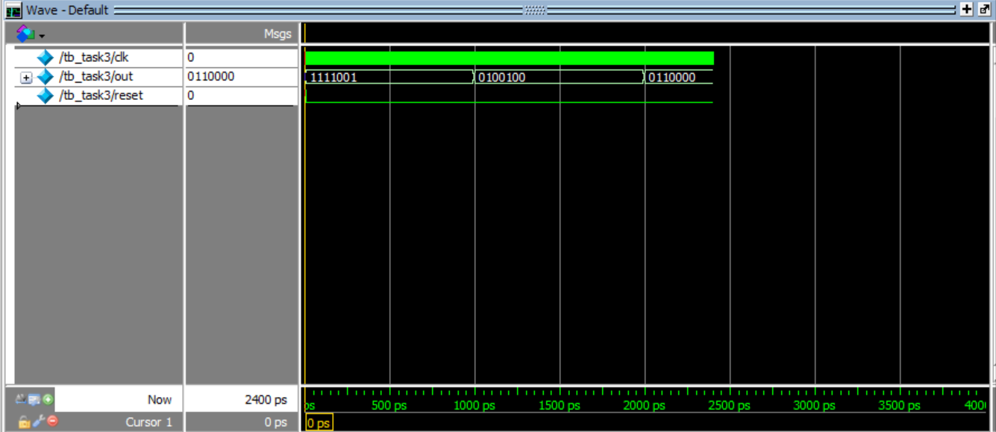

Code:
DUT Code: (For 8-bit Ring Counter)
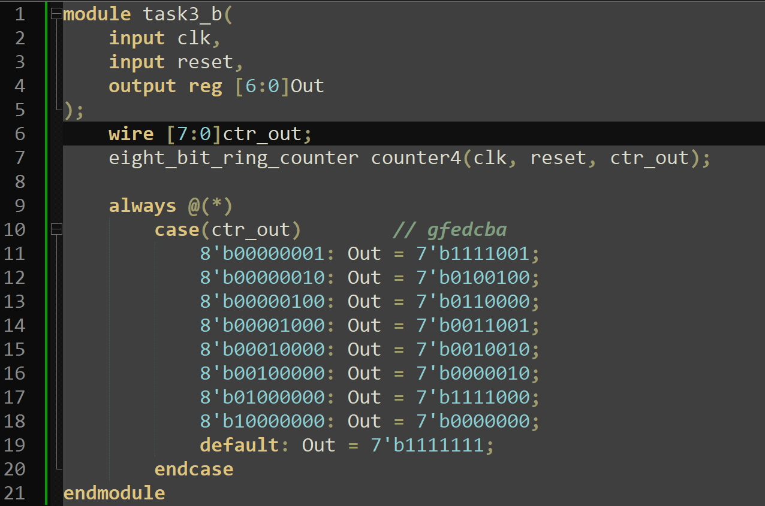

Test bench Code: (For 8-bit Ring Counter)
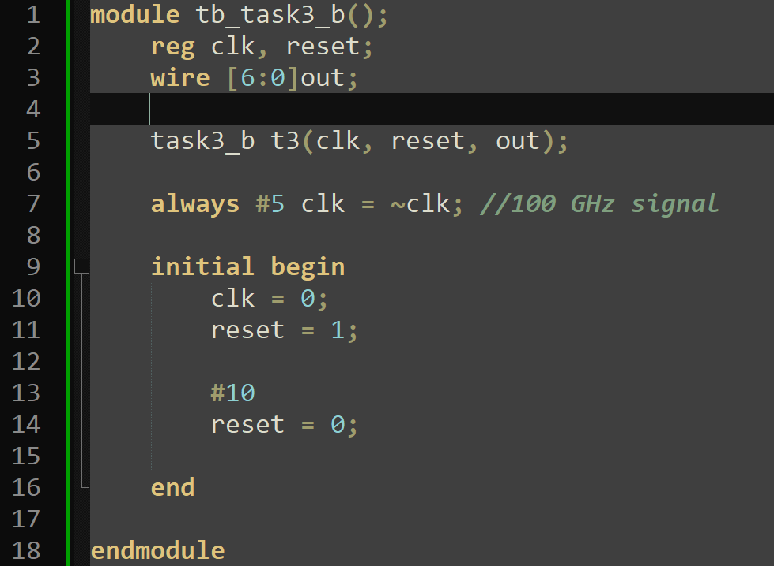

Output: (For 8-bit Ring Counter)
